This is from Outlook. The Equipment section does display anything. You cannot select any of the radio buttons. The unsubscribe button also turns to white when you hover over it.

Gmail Web Client displayed all the divs the radio buttons were supposed to cycle through. The hover does not do anything for the unsubscribe.

Yahoo Web Client shows the div correctly. But it is unable to cycle through the different radio buttons. Hover the unsubscribe button does change the font and background colors.

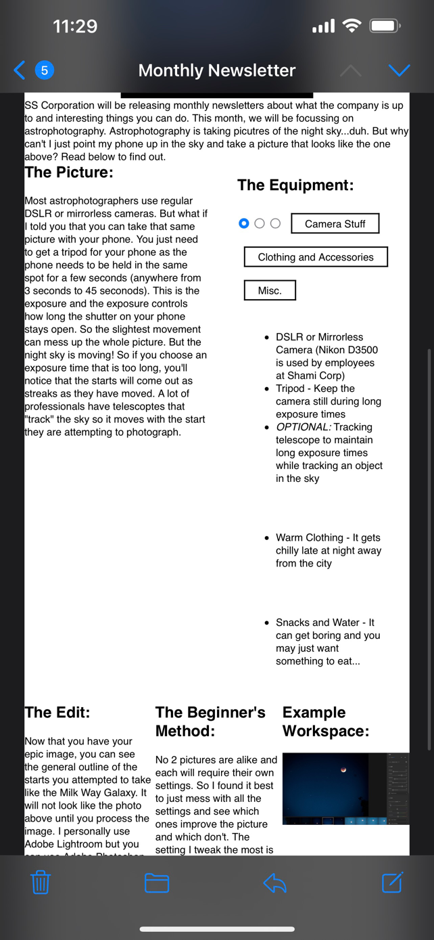

Apple Client displayed all the divs at one time. Buttons cycle but do nothing. Hover effect does not work on mobile.

GMAIL app from android stacks everything. Radio buttons like the web client. Hover no work.